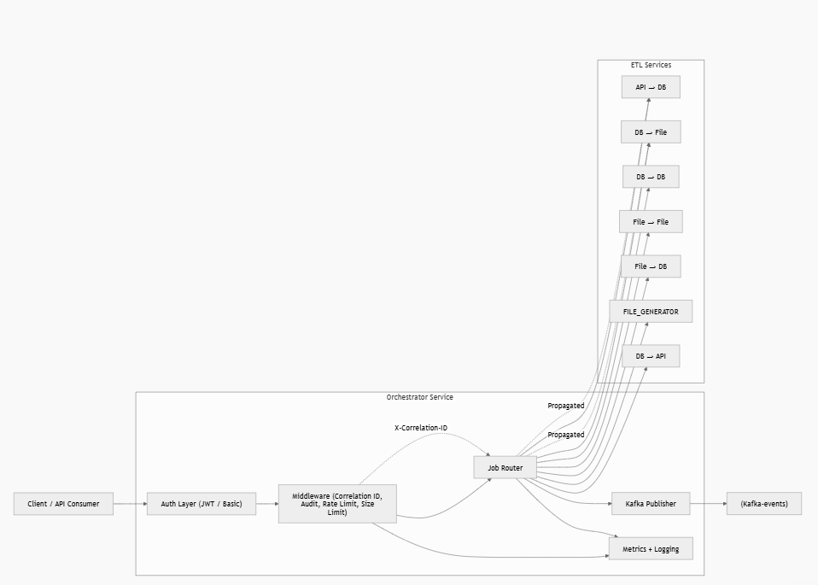

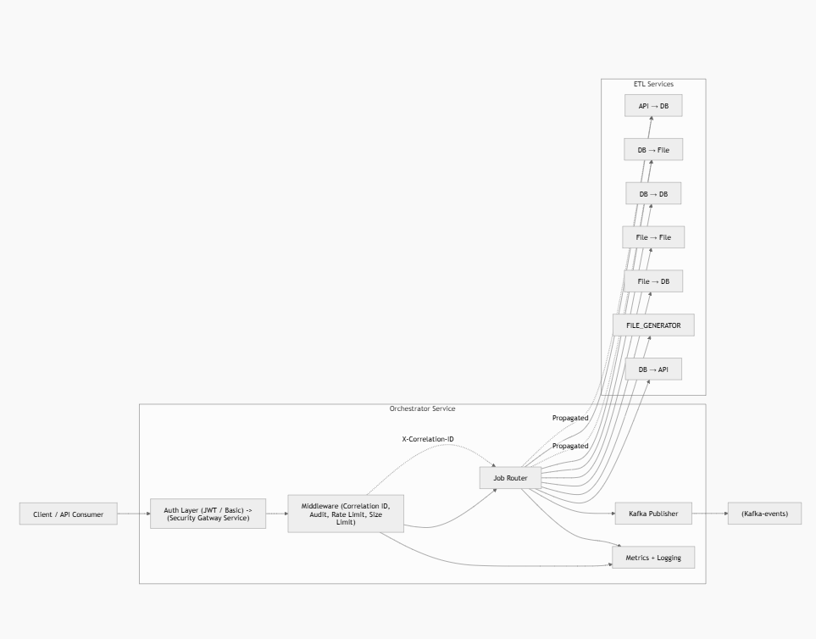

ETL Orchestrator Service – Technical Documentation & Runbook

1. Overview
The Orchestrator Service is the central control layer for all ETL operations in the system.
It performs:
- Routing of ETL jobs to appropriate sub-services
- Publishing job lifecycle events to Kafka
- Maintaining job status tracking
- Providing observability (metrics, logs, audit)
Tech Stack
- FastAPI (Async)
- Python 3.11+
- Kafka (Event streaming)
- Prometheus (Metrics)
- JSON-based persistence (job tracking)
Default Port: 9000
Base URL: http://<host>:9000

2. Core Responsibilities

2.1 Job Routing
Routes incoming requests based on job_type to specific ETL services.
Job Type | Service | Endpoint
api-to-db | API ingestion | /ingest/jsonpull
db-to-file | Export DB → File | /export/dbtofile
db-to-db | DB transfer | /transfer
file-to-file | File conversion | /convert
file-to-db | File ingestion | /ingest/fileload
file-transfer | File movement | /transfer
db-to-api | DB → API push | /export/dbpush

2.2 Event Publishing (Kafka)
Each job generates lifecycle events:
- STARTED
- COMPLETED
- FAILED
Events are published to:
- Topic: etl-events
- Includes:
  - job_id
  - job_type
  - metadata
  - result / error

3. API Endpoints

3.1 Execute Job
POST /jobs
Triggers ETL job execution.

3.4 Health Check
GET /health
Returns:
- service status
- kafka status
- audit status

3.5 Metrics
GET /metrics
Prometheus-compatible metrics.

3.6 List Services
GET /services
Returns all configured downstream services

4. Job Execution Flow
Client → Orchestrator → Sub-service → Orchestrator → Client
↓
Kafka
Detailed steps:
- Request received
- Job ID generated (if not provided)
- Job stored in status store
- STARTED event published to Kafka
- Request routed to sub-service
- Sub-service executes
- Response received
- Job status updated
- COMPLETED / FAILED event published
- Response returned to client

5. Request Payload (IMPORTANT)

5.1 Request Model
{
"job_type": "api-to-db",
"payload": {},
"job_id": "optional-id",
"metadata": {
"user": "admin",
"environment": "prod"
}
}

5.2 Field Breakdown
Field | Type | Required | Description
job_type | string | ✅ | Type of ETL job
payload | object | ✅ | Job-specific config
job_id | string | ❌ | Auto-generated if missing
metadata | object | ❌ | Additional tracking info

5.3 Supported job_type values
- api-to-db
- db-to-file
- db-to-db
- file-to-file
- file-to-db
- file-transfer
- db-to-api

⚠️ Important Observation (From Code)
The orchestrator does NOT validate payload structure.
👉 It simply forwards payload to sub-services.
So:
- Payload errors → Fail inside sub-service
- Orchestrator will only return propagated error

6. Response Model
{
"job_id": "uuid",
"job_type": "api-to-db",
"status": "COMPLETED",
"result": {},
"error": null,
"duration_ms": 1234,
"started_at": "...",
"completed_at": "..."
}

7. Authentication
- Uses:
  - JWT OR
  - Basic Auth
Validated via:
verify_jwt_or_basic

8. Correlation ID (Critical for Debugging)
- Automatically injected via middleware
- Propagated to downstream services:
X-Correlation-ID
👉 This is your primary debugging key across services

9. Security & Limits
Feature | Details
Request size limit | 10 MB
Rate limiting | 10 req/min
CORS | Enabled
Auth | JWT / Basic

10. Observability

10.1 Logs
- Structured logging
- Includes:
  - job_id
  - job_type
  - correlation_id

10.2 Metrics
- Success count
- Error count
- Latency

10.3 Audit
- External service calls tracked
- Kafka-based audit events

11. Kafka Configuration
Environment variables:
KAFKA_BOOTSTRAP_SERVERS
KAFKA_TOPIC
KAFKA_SASL_USERNAME
KAFKA_SASL_PASSWORD
KAFKA_SECURITY_PROTOCOL

12. Failure Scenarios & Debugging Runbook

12.1 Job Failed

Step 1: Get Job Details
GET /jobs/{job_id}
Check:
- status
- error message

12.2 Check Logs
Search using:
- job_id
- correlation_id

12.3 Identify Failure Source
Symptom | Likely Cause
4xx error | Bad payload
5xx error | Sub-service failure
timeout | Downstream service slow/unreachable
empty response | Serialization issue

12.4 Validate Downstream Service
- Check service health
- Hit endpoint directly
- Verify URL config

12.5 Kafka Issues
Symptoms:
- Missing events
- No STARTED/COMPLETED logs
Check:
- Kafka bootstrap server config
- SASL credentials
- Network/firewall
Note:
👉 System continues even if Kafka fails (graceful degradation)

12.6 Job Not Found
Possible reasons:
- TTL expired (7 days)
- Service restart without persistence
- Incorrect job_id

12.7 Correlation Debugging (Best Practice)
GET /jobs?correlation_id=xxx
Use this to:
- trace entire flow
- identify partial failures

13. Common Issues & Fixes
Issue | Fix
Invalid payload | Validate against sub-service spec
Service unreachable | Check service URL/env config
Auth failure | Validate JWT / credentials
Rate limit hit | Reduce request frequency
Large payload rejected | Reduce size (<10MB)

14. Operational Notes
- Job store is file-based → not suitable for high scale
- No retry mechanism → handled externally
- No queueing → synchronous execution
- Sub-service timeout: 300 seconds

15. Key Takeaways (Important for Support Team)
- Orchestrator is NOT doing business logic
- It is:
  - router
  - event publisher
  - tracker
- Most failures = downstream issues
- Always debug using:
  - job_id
  - correlation_id

📄 Orchestrator Service – Confluence Page

🔷 Orchestrator Service

🔹 Overview
The Orchestrator Service is responsible for executing data processing jobs based on incoming API requests.

🔹 API Endpoints

🔸 POST /jobs
✅ Description
Triggers a job execution (e.g., DB → file extraction).

🔸 Request Payload
{
"job_type": "db-to-file",
"job_id": "test-db-to-file",
"payload": {
"file": {
"type": "delimited",
"output_path": "Inbound/",
"filename_prefix": "users",
"header": true
}
}
}

🔸 Response
{
"job_id": "test-db-to-file",
"job_type": "db-to-file",
"status": "COMPLETED",
"result": {
"status": "OK",
"records": 20,
"file": "/files/Inbound/users.csv",
"duration_ns": 573,
"error": null
},
"started_at": "2026-03-19T18:13:12.160575",
"completed_at": "2026-03-19T18:13:13.382183"
}

🔹 Execution Flow
- Client sends POST request to /jobs
- Orchestrator validates payload
- Job is executed immediately
- Data is processed (DB → file)
- File is generated in target location
- Response is returned with status and metadata

🔹 Error Handling

🔸 404 Not Found
{
"detail": "Not Found"
}
Cause:
- Invalid endpoint (e.g., /jobs/{job_id} not supported)

🔸 405 Method Not Allowed
{
"detail": "Method Not Allowed"
}
Cause:
- Using unsupported HTTP method (e.g., GET instead of POST)

🔸 422 Validation Error (Expected)
Occurs when request payload is invalid or missing required fields.

🔹 Important Design Behavior

🔸 No Job Status API
The following endpoint is NOT supported:
GET /jobs/{job_id}
Reason:
- Jobs are executed synchronously
- Status is returned in POST response itself

🔸 Synchronous Execution
- No queueing
- No background processing
- No polling required

🔹 Logs & Debugging
When debugging issues, check:
- Request payload correctness
- API response status
- Execution time (duration_ns)
- File path output
- Error field in response

🔹 FAQs

❓ How to check job status later?
Not applicable — job completes during POST call.

❓ Why is GET /jobs/{id} not working?
Because the endpoint is not implemented in this service.

❓ How to confirm job success?
Check:
- "status": "COMPLETED"
- "error": null
- Output file path exists

🔹 Future Enhancements (Optional)
- Introduce async job execution
- Add job status API (GET /jobs/{id})
- Add retry mechanism
- Add job history tracking

✅ How to paste into Confluence
After pasting:
- Select section titles like:
  - Orchestrator Service → set to Heading 1
  - Overview, API Endpoints → Heading 2
  - POST /jobs → Heading 3
  - Request Payload → Heading 4 (optional)
- Use:
  - /code block for JSON
  - /panel for notes (optional)

